What are the FRCPath Courses in the EoE

Welcome to the EoEPathology.com site.
Purpose of this flier-is to explain the remit of the range of educational course we run in the EoE and how to plan a campaign to clear the exam in the one sitting (not guaranteed).

Why and who should attend the course?
- Any FRCPath trainee who has cleared part 1 of the FRCPath examination (in stage C) will benefit. The course broadly covers the entities likely to be encountered in clinical practice and in the exam setting.
- The timing of attending the course is dependent on the stage of the training. Knowledge acquisition is not the remit for those sitting the exam 6-8 weeks later. Here it is a case of refreshing their knowledge and understanding exam technique and maximising their scores.
- Those sitting the exam 6 months or later would be benefitting from knowledge acquisition and there is the expectation of sufficient optical miles before attending the course.

Systemic Histopathology Course:
Preparatory course for the FRCPath, aimed at ST3 upwards, covering the range of cases that are likely to come up in clinical practice and at the exam. The courses run in February and September, 6 to 8 weeks before the FRCPath examination. There is much emphasis on how to clear the examination by maximising scores for all components of the examination.

Daily Time table for the FRCPath Course:
 | Slide Viewing | Slide-based discussion | Slide Viewing | Slide-based discussion | Slide Viewing | Slide-based discussion
Slide Viewing | 8 am –10.30 am |  | 1.30 pm-3.30pm |  | 5.30 pm- 6.30 pm
 |  | 10.30 am-12.30 pm |  | 3.30 pm-5.30 pm |  | 6.30 pm – 8.00 pm
Mock Exam 1st Saturday of course

The Physical Course:
- The Faculty is composed of senior Consultants, experts in their field.
- Timing: Mon-Friday (10 days) intense 8 am to 8 pm (most days)
- Format of the Course: The course is primarily slide-based with the moderators talking through the cases, after each of the slide viewing sessions (see below of indicative timetable).
The Online Course:
- Scanned slides are incorporated into a teaching app (works on android and IOS tablets or smart phones.
- The attendees view the scans and clinical details following the same timetable remotely (see above).
- The case discussions take place via the zoom app and both physical and online candidates are invited to participate. These sessions are recorded and hosted on vimeo.com and incorporated into the app for viewing at a later date. Power point presentations are likewise embedded into the app for viewing at a later date.
- Access to course materials through the app: Access is not perpetual-TBC at a later date.
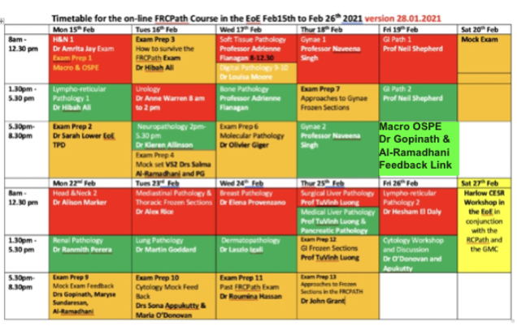
Course Content: See indicative Course Timetable (below). Apart from the main systemic pathology topics covered 10 separate sessions are devoted to help maximise scores. These include sessions to give aspirants visibility of their foibles in writing written scripts, justifying answers, maximising scores for each case (given forced errors are likely) and preparation for the OSPE and viva sessions.

The Cytology Course-see Cytology Flier:
The course consists of online and a physical presence. The hybrid online course provides a different experience for those attending physically since there is access to a large library of slides in the EoE Cytology Workshop.
The online experience is once again delivered through the course app-downloadable, a weekend before the beginning of the course.

Prepinars:
Who should attend: All FRCPath aspiring trainees and Consultants within 18 months of sitting the FRCPath. This September sees the fourth of these Prepinar series. Feedback from successful candidates has been absolutely unbelievably complimentary. The RCPath meanwhile noticed a marked jump in the pass rate for the FRCPath from about 40% to over 70%. We take comfort in the knowledge that we are partly instrumental in helping candidates clear the exam. Many of the FRCPath aspiring Consultants from overseas do not have an understanding of the expectation of the examiners. We strive to give you insight into the expectation of the examiner and also how to maximise your knowledge, to clear the exam.

Non-UK Trainees and Consultants: The FRCPath is an English, UK-based examination with a strict training programme spanning 4 years. The trainees have numerous experiential opportunities with exposure to a varied clinical setting, DGH setting, specialist unit placements and University setting. During this period of training, the skill of writing a structured reasoned report, describing the findings on H&E, followed by a comment justifying and interacting with the clinical team with a definitive diagnosis or proposing the need to resort to special or immuno-stains. A definitive diagnosis if safe is also stated in the conclusion. This form of training is not the norm in many countries.

During the Prepinars in the EoE we strive to ingrain the culture of writing structured reports-improving the layout of the script, adding additional text to exemplify to the examiner our understanding of the subject matter.

Course Structure:
- When do they happen?: Daily Prepinars run for a duration of 10 to 16 days in the run up to the exam. This is the time when all trainees preparing for the exam are hungry for slides/cases having mostly exhausted all slide libraries and collecions.
- How do they happen?:The subject matter tends to be new series of cases most drawn from a large library of digitised slides in the EoE. We aim to cover 20 cases daily over 14 days (approx. 300 exam standard cases).
- Mode of course delivery: Word files with urls and clinical details are sent through a group wattasp text and others access through the course app. The sessions happen daily between 2 pm – 4 pm.
- The sessions are delivered through Zoom and videoed session embedded in course app.
- Pdf of Powerpoint presentations are embedded in the course app for ease of access for attendees.

Webinars in the EoE:
- Who should attend?:
- All pathologists in clinical practice and all trainee or FRCPath exam aspiring overseas consultants should attend.
- Why attend? The sessions are moderated by senior Consultants, many experts in their field. This would be an opportunity to ‘up your game’ and become updated in your working clinical knowledge. The choice of speaker and content relates to interesting topics which have evolved over the last 10 years and major changes in diagnostic practice.
- Course delivery: Each of the sessions will delivered on zoom and will be slide-based. Very rare lecture-based sessions will also take place as updates.
- Each session will have up to 20 cases, which will be available through ipad or android tablet-based course app. The cases for next week’s sessions will be available usually by the Monday preceding the session.
- Attendees will be advised to update their app on a weekly basis to get new course content.
- Interactive sessions will be broadcast on zoom and recorded videos will be embedded in the course app-a week later.

- Slide workshops: These run as ‘Physical” only sessions at Harlow Hotel or at the Holiday in Express, Harlow. Attendees will have the opportunity to follow the Prepinars during these sessions.
- This gives the opportunity to look through 1000’s of exam standard slides in your own time.
- This is refresher for those seeking to hone their diagnostic skills and improve their speed in coming to a diagnosis.
- Speed is of the essence in preparing for the exam. In preparing for the exam, the diagnosis for anyone case should crystalise within seconds, if not a minute, leaving the remaining 9 mins to craft a structured answer to maximise your scores.

Plan for someone Sitting the Exam in October 2021 and in quarantine:
Arrive in the UK and quarantine -whilst in quarantine
Follow our Main course starts 7th September -17th September
Follow our physical or online Cytopathology Course 20th to 24th September
Attend the slideworkshop at Holiday in Express 26th September to 10th October and or if physical slide workshop is not a feasible option-follow our Prepinars (26th Sept to 10th Oct).

Plan for someone Sitting the Exam in October 2022:
Follow our Webinars
Follow Season 1 webinars – ends Aug 2021
(If you subscribe to season 1, and season 2 you have the option of accessing season 1 and 2.)
Follow Season 2 Webinars – ends July 2022

Follow our Histopathology Course Sept 2022
Follow our Cytopathology Course Sept 2022
Follow our Prepinars September 2022 to October 2022

